**Pizza Sales Query Report**

Excel | Tableau | Power BI

1. **Query results for KPI’s:**
2. Total Revenue:

Select ROUND(SUM(total_price),2) as Total_revenue

From pizza_sales

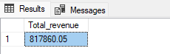

1. Avg Order Value:

select ROUND(SUM(total_price)/COUNT(DISTINCT order_id),2) as avg_order_value

from pizza_sales

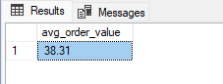

1. Total Pizzas Sold/ Total Quantity:

select SUM(quantity) as total_pizzas_sold

from pizza_sales

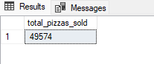

1. Total orders placed:

select COUNT(Distinct order_id) As Total_orders

from pizza_sales

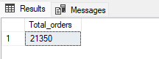

1. Average pizzas sold per order:

select CAST(CAST(SUM(quantity) as DECIMAL(10,2))/CAST(COUNT(DISTINCT order_id)as DECIMAL(10,2)) as DECIMAL(10,2)) as avg_pizza_per_order

from pizza_sales

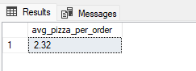

1. Query results for Charts & Visualizations:
2. Daily Trend for Orders

SELECT DATENAME(WEEKDAY,order_date)as order_day,COUNT(DISTINCT order_id) as Orders

FROM pizza_sales

Group by DATENAME(WEEKDAY,order_date)

order by DATENAME(WEEKDAY,order_date) desc

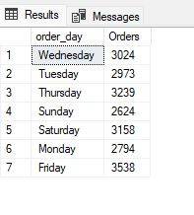

1. Hourly Trend for total Orders:

SELECT DATEPART(HOUR,order_time) as hourly_trend,COunt(DIstinct order_id) as Orders

FROM pizza_sales

GROUP By DATEPART(HOUR,order_time)

ORDER BY DATEPART(HOUR,order_time)

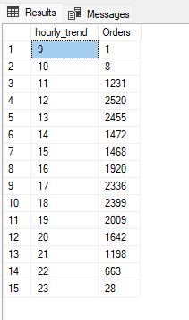

1. Monthly trend for total orders:

select DATENAME(MONTH, order_date) as Month_Name, COUNT(DISTINCT order_id) as Total_Orders

from pizza_sales

group by DATENAME(MONTH, order_date)

order by Total_Orders desc

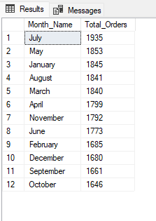

1. Weekly Trend for Total Orders:

select DATENAME(ISO_WEEK, order_date) as Week_Number, COUNT(DISTINCT order_id) as Total_Orders

from pizza_sales

group by DATENAME(ISO_WEEK, order_date)

order by Total_Orders desc

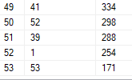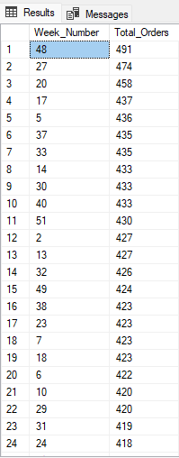 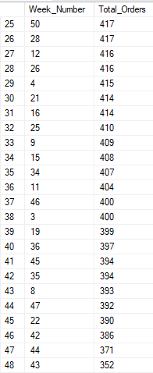

1. Percentage of sales by pizza Category:

SELECT pizza_category, ROUND(SUM(total_price),2) as total_sales,

ROUND(SUM(total_price)/(SELECT SUM(total_price) from pizza_sales)*100,2) as percent_sales

From pizza_sales

group by pizza_category

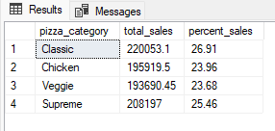

1. Percentage of sales by pizza Size:

SELECT pizza_size, ROUND(SUM(total_price),2) as total_sales,

ROUND(SUM(total_price)/(SELECT SUM(total_price) from pizza_sales)*100,2) as percent_sales

From pizza_sales

group by pizza_size

order by percent_sales desc

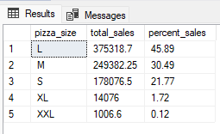

1. Total pizza sold by pizza category:

SELECT pizza_category, SUM(quantity) as Total_quantity

from pizza_sales

group by pizza_category

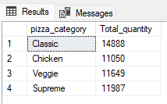

1. Top 5 pizzas by revenue:

SELECT TOP 5 pizza_name, SUM(total_price) as total_revenue

from pizza_sales

group by pizza_name

order by total_revenue desc

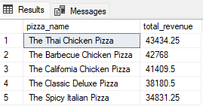

1. Bottom 5 pizzas by revenue:

SELECT TOP 5 pizza_name, SUM(total_price) as total_revenue

from pizza_sales

group by pizza_name

order by total_revenue

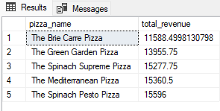

1. Top 5 pizzas by quantity sold:

SELECT TOP 5 pizza_name, SUM(quantity) as total_quantity_sold

from pizza_sales

group by pizza_name

order by total_quantity_sold desc

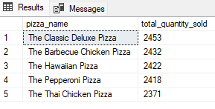

1. Bottom 5 pizzas by quantity sold:

SELECT TOP 5 pizza_name, SUM(quantity) as total_quantity_sold

from pizza_sales

group by pizza_name

order by total_quantity_sold

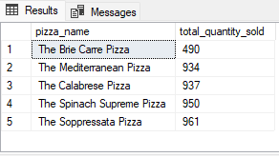

1. Top 5 best pizzas by total orders:

SELECT TOP 5 pizza_name, COUNT(DISTINCT order_id) as total_orders

from pizza_sales

group by pizza_name

order by total_orders desc

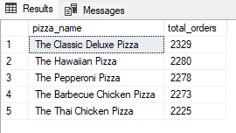

1. Bottom 5 pizzas by total orders:

SELECT TOP 5 pizza_name, COUNT(DISTINCT order_id) as total_orders

from pizza_sales

group by pizza_name

order by total_orders

